|  |
| --- |
|  |
| A Level Computer Science Project |
|  |

|  |
| --- |
| Riyad Zamil Ahmed  Candidate Number: 7025  Centre Number: 110022 |

Contents

1) Analysis 3

1.1) Features that make the problem solvable methods 3

1.1.1) Problem Descriptions 3

1.2) Suitable stakeholders 4

1.3) Information gathering 6

1.4) Existing Solutions 8

1.5) Features of proposed computational 13

1.6) Limitations of the proposed solutions 14

1.7) Requirements for the solution including hardware and software requirements 15

1.7.1) Software Requirements 15

1.7.2) Hardware Requirements 15

1.7.3) Design and Functionality Requirements 15

1.8) Success Criteria 16

2) Design 16

2.1) Decomposing the Problem 0

2.2) Structure of the Solution 2

2.3) Algorithms 5

2.4) Usability features 6

2.5) Key Variables / Data Structures 6

2.6) Test data during the iterative development 7

2.7) Further data to be used in the post development phase 13

3) Iterative development of a coded solution 14

3.1) Prototype versions 14

3.2) Main Menu Prototype 17

3.3) Login Page Prototypes 19

3.4) Sign-Up Page Prototype 20

3.5) Display Review Prototypes 26

3.6) Create Review Protoypes 27

3.7) Review of Solution 27

4) Testing to inform development 29

4.1) Testing at each stage of the iterative development process 29

5) Testing to inform evaluation 30

5.1) System Testing and End user testing 30

6) Evaluation of solution 31

6.1) Evaluate the solution 31

6.2) Further development. 31

6.3) Effectiveness of usability features. 31

6.4) Maintenance issues and limitations of the solution. 31

6.5) Limitations and potential improvements / changes. 31

# 1) Analysis

## 1.1) Features that make the problem solvable methods

### 1.1.1) Problem Descriptions

Nathan Adelakun is the owner of Saviorities Studios that specializes in journals about gaming. They are a startup company and want to add more to the gaming field. They were founded recently with only a few members just have grown exponentially in the past couple of months. (Need more detail)

Creating a review app for games presents a unique opportunity to cater to the diverse needs and preferences of gaming enthusiasts. By focusing on key points such as enabling users to review games, implementing a clan system, providing up-to-date information about games, and incorporating a tracking system to manage users' gaming history, an engaging and comprehensive platform can be developed to enhance the gaming experience.

Reviewing Games:

Central to the review app for games is the functionality that allows users to review and share their experiences with different games. This feature empowers users to express their opinions, provide ratings, and offer insights into the gameplay, graphics, storyline, and overall enjoyment of the games they have played. Users should have the ability to craft detailed reviews, including pros and cons, personal anecdotes, and recommendations for other players. The review system should encourage constructive feedback and facilitate meaningful interactions among the gaming community.

Creating a Clan System:

Introducing a clan system within the review app for games can foster a sense of camaraderie and collaboration among users. This feature enables gamers to form or join clans based on shared interests, gaming genres, or specific titles. Clans provide a platform for members to engage in discussions, organize multiplayer sessions, and participate in clan-specific events and challenges

Tracking System to Manage Played Games:

Implementing a tracking system that allows users to manage and track the games they have. This feature enables users to create a library of their played games, complete with playtime statistics, achievements unlocked, and personal reviews or ratings. The tracking system can also suggest similar games based on a user's preferences and playing history, facilitating game discovery and enhancing user engagement.

They have also requested a way to search and sort games alphabetically, games released after dd/mm/yyyy or for x console. They also wish to add a group system for clients to join groups, discuss about common games the group plays and to organise tournaments between them and other groups.

## 1.2) Suitable stakeholders

|  |  |  |  |
| --- | --- | --- | --- |
| Stake Holder | Role | Interaction | Availability |
| Samuel Naylor | Independent Game Journalist | * Reviewing the program * Providing feedback * Gaining attraction for the app | Every day |
| Nathan Adelakun | Owner | * Reviewing the program * Hired Specialists | Twice a month |
| Kookai Kawamoto | Head Manager | * Reviewing the program * Investigating what users would like * Analytics of the app | Weekly |
| Alicia Daley | Design Lead | * Develops the design for the program * Provides design feedback for user with disabilities | Weekly |
| Toby Baker | Tester | * Tests app for bugs * Provides feedback for overall experience for the program | Every day |

The target audience of the app is for reviews and gamers to scribe and post their honest opinion on the games they may or may not enjoy. The client wants to minimise the amount of backlash users of the app will get so they want to implement the reviews as view only for all reviews weather they are made by companies or users. There will be no overall score rating for games since troll posts can be common and negatively impact customer experience and hurt a game’s reputation due to users’ review bombing a game they do not like. Users can also use the inbuilt tracker function of the app to track what games they have played with features to add it to one of five categories: Plan to play, Playing, Completed, Dropped, 100% done.

User will also be able to join a Syndicate, which are clans, for the games of their choices. They are not restricted to joining a limited number of syndicates so they can join the syndicate of all the games they desire. The aim of the syndicate feature is to inspire a thriving community and encourage finding new friends to play with.

Samuel Naylor is an independent journalist looking for new ways to thrive the gaming community. Many of his articles are big hits and have influenced many player bases of small games, causing them to become hidden gems. Sam is our scout and influencer aiming to promote the program to the masses, providing daily feedback by showing snippets of the app to their contacts.

Nathan Adelakun is in charge of this whole project, directing and brining in the best that he can find to develop this app. He has made many successful projects such as “Gaming Guides” and “Teammate Scouter” and now wishes to create something bigger, a central hub to bring in gamer together. This project is meant to let gamers express their wholehearted opinion and discuss the game with like-minded people. Nathan is only available to meet twice a week.

Kookai Kawamoto is the head manager at Saviorities Studios and is in charge with reviewing the program for final release and finding out what users would like to see and analytics such as popular games, latest game releases etc.

Alcia Daley is the design lead on the app. She has designed many popular apps, creating a mark on the design world. She is here to help make sure the app looks as good as possible for all sorts of users, focusing on those is vision impairment so that anyone and everyone can use apps that she has worked on. Her expertise on the subject will create a beautiful GUI attracting the eye on many who look at the app.

Toby Baker is a gamer that is interested in a review app and is hired as a bug tester to check if anything is not working if it’s supposed to. Toby has a knack for finding bugs in all sorts of programs and expressed interest in helping out.

## 1.3) Information gathering

I carried out an interview with the clients and they want an application that allows users to review games that they have played to let other users know what X game is like. They also want to include a Syndicate system to allow uses to join a group and discuss about games and organize in-clan and clan-vs-clan based tournaments with the brackets created internally by the program. On top of this, they wish to add a forum segment to write tutorials and help others that are stuck in a game. The team also expressed an interest in the design and layout of the program, wanting to include as many users as possible into the app and emphasizing on those who have trouble with reading text.

I also carried out a questionnaire for the program about what features potential users would want to see and the results from over 50 people are shown below.

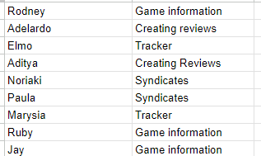

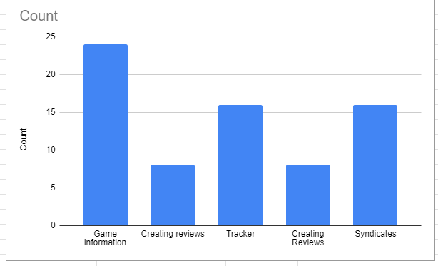

The results of the questionnaire regarding the features for the app have provided valuable insights into the preferences of the users. The overwhelming feedback indicates a strong desire for the inclusion of an information page and the syndicate system within the app. These features have been highlighted as crucial elements that would significantly enhance the user experience and engagement with the platform.

Information Page: Users have expressed a clear need for an information page within the review app. This page would serve as a centralized hub for accessing comprehensive details about the various games. The users have emphasized the importance of having access to accurate and up-to-date information that can aid them in making informed decisions. They seek detailed descriptions, and relevant data that would enable them to gain a deeper understanding of the games being reviewed. Additionally, users have expressed the need for the information page to feature user-generated content, such as tips, FAQs, and supplementary details shared by the community which we will be adding into the forums page. This collaborative approach to information sharing has been identified as a key factor in fostering a sense of trust and reliability within the app.

Syndicate System: The inclusion of a syndicate system has emerged as a highly anticipated feature among the respondents. Users are eager to connect with like-minded individuals who share similar interests, preferences, and expertise. The implementation of a clan system would enable users to form and join specialized groups based on the game of their choice. This would provide meaningful interactions, discussions, and knowledge-sharing opportunities within the app. Furthermore, users have highlighted the potential for the clan system to enhance social engagement, promote user loyalty, and create a sense of belonging within the community. The ability to collaborate with clan members, participate in group activities, and collectively contribute to the review app creates a desire for users to actively participate in the app.

## 1.4) Existing Solutions

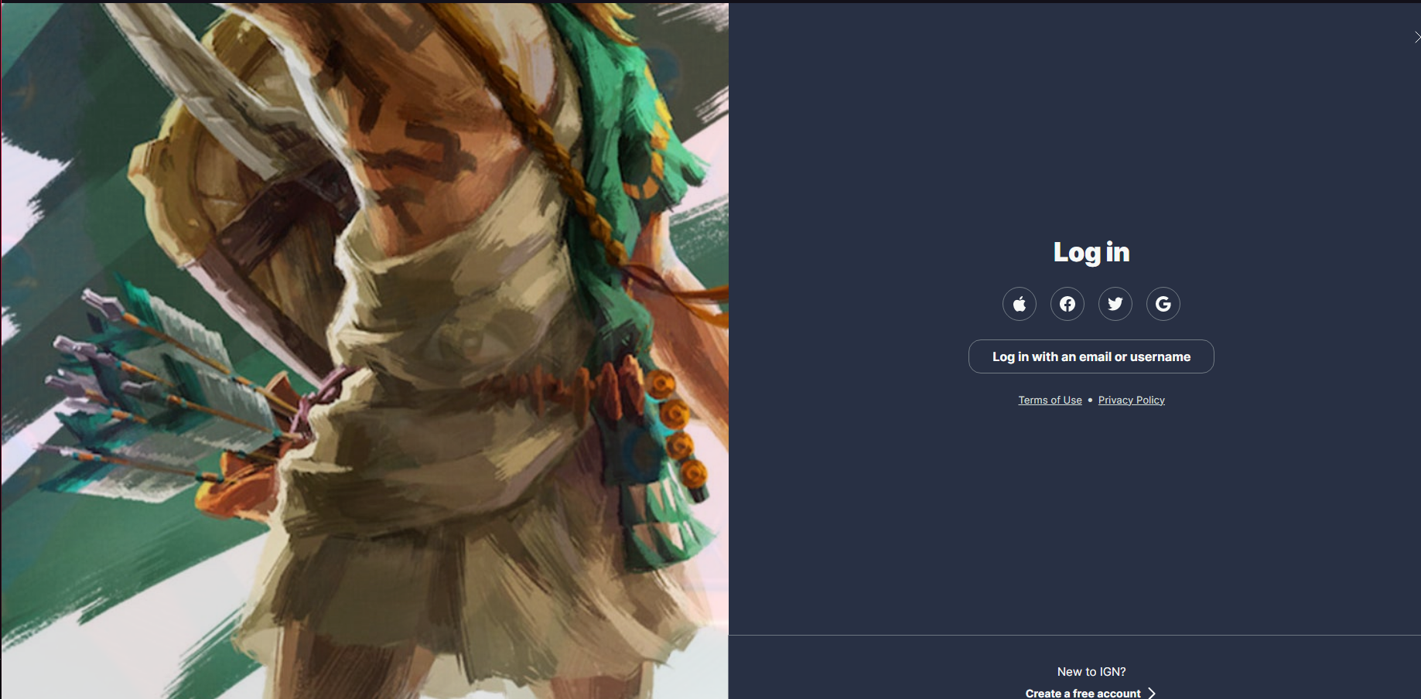

**Figure 1.1**

IGN’s login page gives us many third-party ways to login like using your google or Facebook account, which is a great way to login in as many people already have accounts from these third-party companies which have a continuously updated API so many people can login using these methods as an alternative than registering straight to IGN. The image to the side of the login page changes constantly to reflect new games and other pieces of media. They chose a simple colour palette of two colours, a dark blue and white, which doesn’t distract the end user. The UI itself is clean and simple, no distractions and to the point. There are no unnecessary extras added to the login page like advertisements or pop-ups. Furthermore, at the bottom of the sign in page, there is a link to reset your password, which is slightly out of sight so the client requested to move the button for that to a more obvious spot when developing the app.

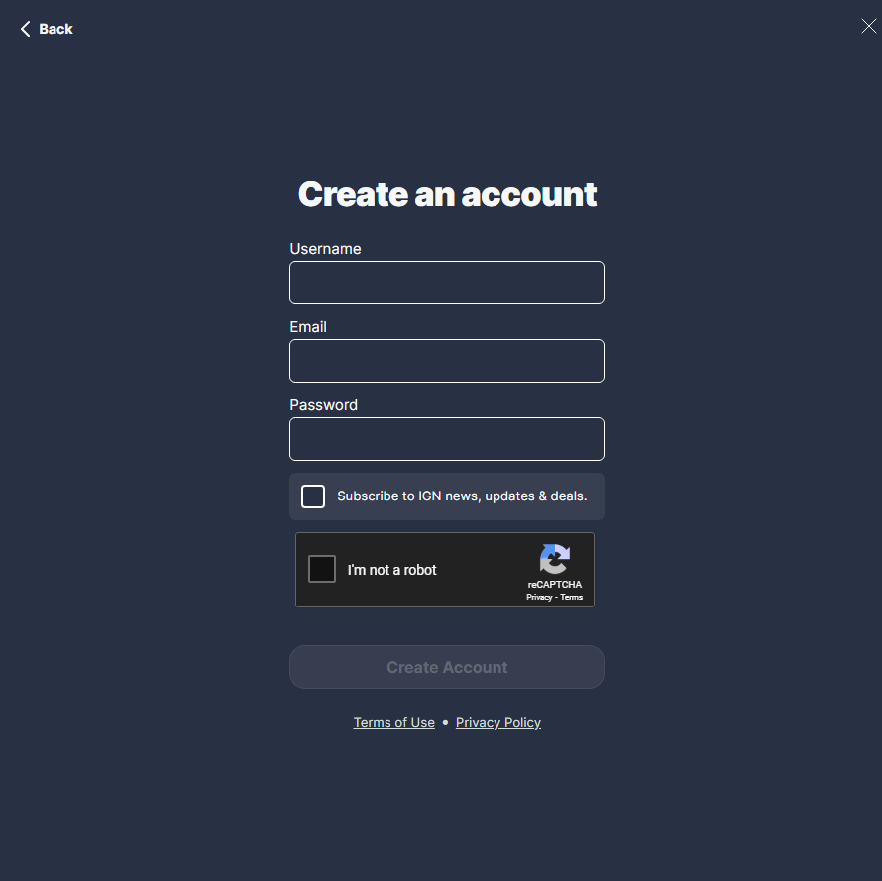

**Figure 1.2**

The Register page includes a username being a name to each and every person which with people a sense if uniqueness and highly customizable by using many different Unicode characters but has to be different to anyone else’s username, an email address which allows emails to be sent from the website into the users inbox if something big happens, like the new final fantasy being released or newsletters being sent. After a new user makes an account, a prompt to sign up to the newsletter will appear. Included in the register process is a ReCAPTCHA box to prevent bot accounts from being made to help prevent DDoS attacks and stops abuse of free trails. There is a “register” button that signs you up to the websites page which will add the login details to a database.

**Takeaway from IGN**

* Simple colour palette
* 3rd party login methods
* Captcha to ensure less bot accounts are made
* Only necessary customer information is taken (Email, Password, Username)
* Moving the “Reset Password” option to an easier place to see (Not at the bottom of the page far away from the login buttons.)

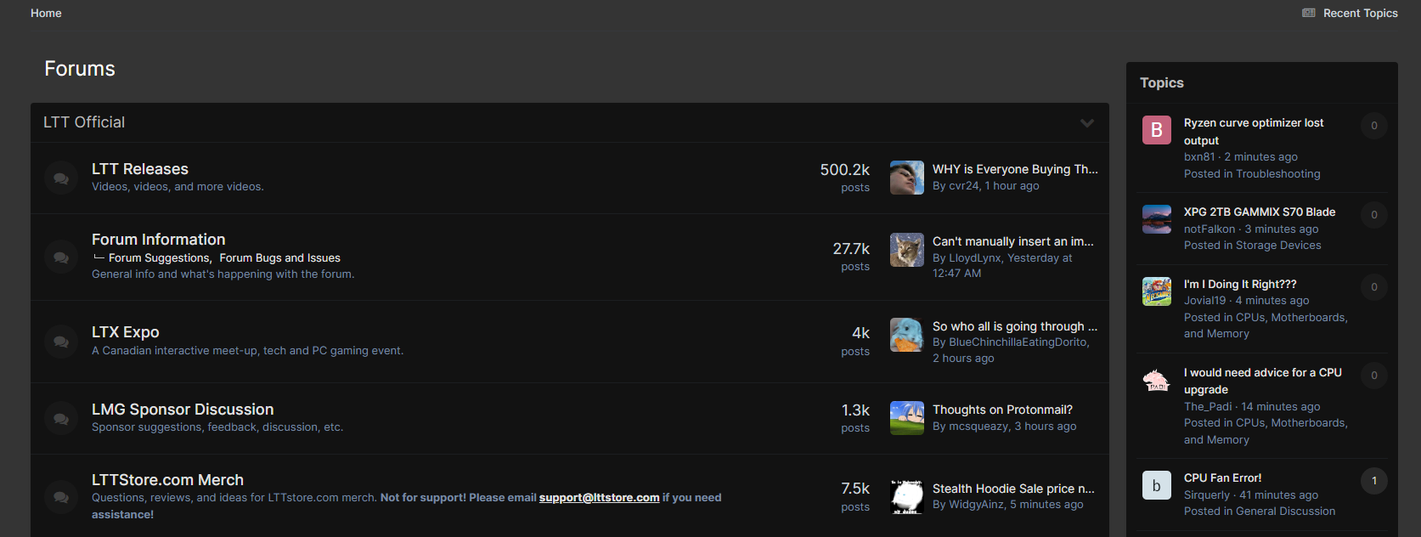

**Figure 2.1**

Linus Tech Tips is a forum website that allows user to post topics as a guide to help others, customers and clients that require help in all aspects related to technology or general inquires. The forum page is split into multiple sections, showing hot topics, guides and new forums that are made. Furthermore, each post has a tag to split them into their respective categories so they are easier to sort out and to search for. One thing I dislike about [**Figure 2.1**] is the basic, two-toned colour scheme. The client wants to change this by adding a frosted box on top of the post and a colour at the corner of the post to show what category the post is sorted into.

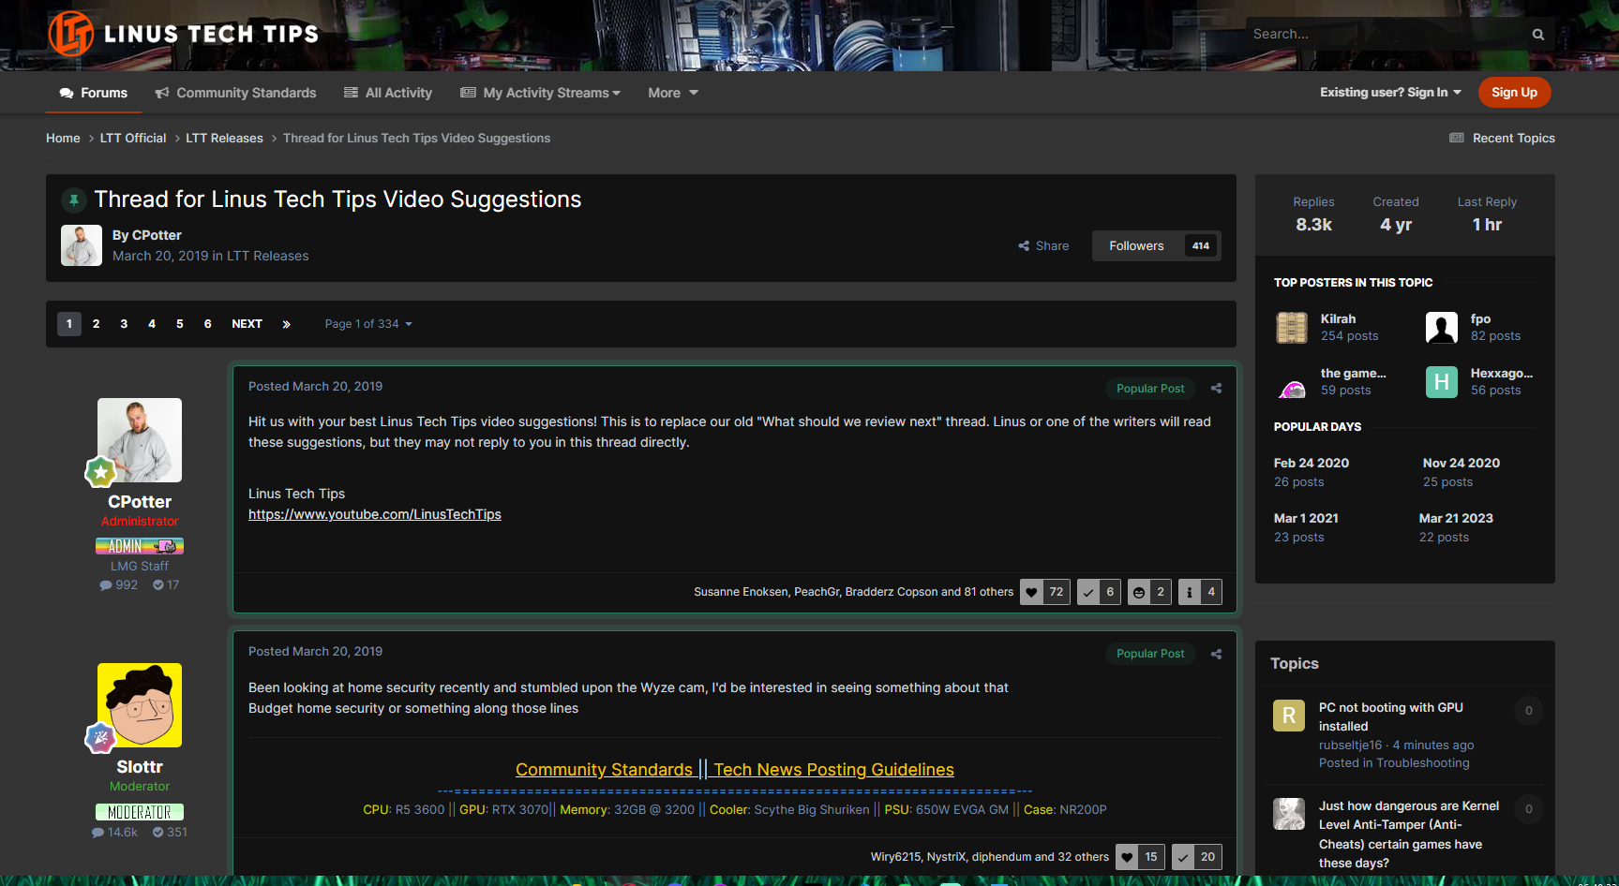

**Figure 2.2**

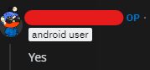

**Figure 2.3**

In [**Figure 2.2**] the user that posts a query is displayed up top, the client wants to add this add an indicator such as “OP” o show they are the original poster of the question like Reddit [**Figure 2.3**]. There are also user ranks, showing if the user is an Admin, Moderator or a regular user, to distinguish between users and power users.

As in [**Figure 2.3**], Users will have flairs under their usernames to distinguish their role in the community, creating a more aware environment when discussing topics and subjects with fellow players.

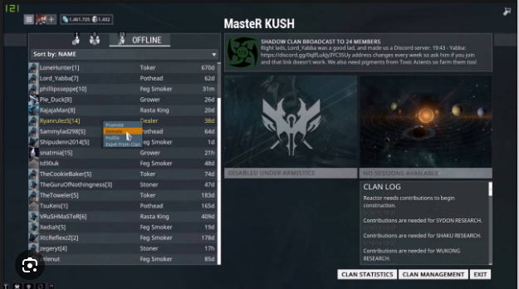

**Figure 3.1**

In [**Figure 3.1**] a clan system in the game ***Warframe*** is shown. This page shows a Clan (Which the clients want to add and rename it to “Syndicates”) with the name of the clan on the top, members list on the left, clan description and emblem top right with activities underneath and at the bottom is a log of actions that has happened within the clan and regarding the clan itself. Each clan as a user ranking system such as regular members, admins and founder. Admins and the Founder can manage the other users such as muting them, kicking them from the clan or banning them from the clan. The clan system is used for competitions with and against of clans which is why the clients would like to add this to the application.

The Clan system will also include a chat system to talk with your fellow clan members to discuss possible organised event in the game, loot tables/drops heling new players to get that hard-to-get piece to finish their build etc. Including a chat system will increase users since it will engage user to talk to each other and create a community around their shared interest

## 1.5) Features of proposed computational

## 1.6) Limitations of the proposed solutions

|  |  |  |
| --- | --- | --- |
| Number | Requirements | Justification |
| 1.1 | Login page |  |
| 1.2 | Hashing and encryption of passwords |  |
| 1.3 | Username and display names |  |
| 1.4 |  |  |
| 1.5 |  |  |
| 1.6 |  |  |

## 1.7) Requirements for the solution including hardware and software requirements

### 1.7.1) Software Requirements

|  |  |  |
| --- | --- | --- |
| Number | Requirements | Justification |
| 1 | Pascal (Delphi) | The coding language of the program. |
| 2 | Microsoft Word | The software used for the documentation for the project |
| 3 | Microsoft Windows 11 | The operating system designed for the program. |

### 1.7.2) Hardware Requirements

|  |  |  |
| --- | --- | --- |
| Number | Requirements | Justification |
| 1 | X86_64 CPU |  |
| 2 | Keyboard |  |
| 3 | Mouse |  |
| 4 | 8 GB RAM |  |
| 5 | 5GB Storage |  |

### 1.7.3) Design and Functionality Requirements

|  |  |  |
| --- | --- | --- |
| Number | Requirements | Justification |
|  | Main Menu |  |
|  | Game Information |  |
|  | Sign Up Page |  |
|  | Log In Page |  |
|  | Log in button |  |
|  | Syndicate Page |  |
|  | Syndicate Button |  |
|  | Sign up button |  |
|  | Tracker Page |  |
|  | Tracker Button |  |
|  | Review Page |  |
|  | Review Author |  |
|  | Review Games |  |
|  | Review Text Box |  |
|  | Create Review |  |
|  | Create Review Button |  |
|  | Text box for Author |  |
|  | Text box for Game |  |
|  | Text Box for Review |  |

## 1.8) Success Criteria

# 2) Design

## 2.1) Decomposing the Problem

**Review Page**

The review page will consist of two parts: View reviews and Creating reviews. This will be 2 separate the page to not over-complicate and clutter the page, making it look cleaner and not a mess of buttons, drop down boxes and edit boxes. This is the main focus of the app.

**View Reviews**

This page will allow the user to see reviews made by other users which are stored locally on the user’s device. The page will have a combo box to select which game and which author wrote the review. The combo boxes will need to filled by searching a database for a list of authors and a list of games to populate them so the users can select them

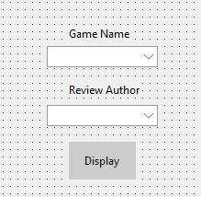

**Create Reviews**

To create a review on the program, the user will need to input the author's name, the game's name, and the review text into the designated edit boxes. The author's name identifies the individual providing the review, while the game's name specifies the title of the game being reviewed. The review text should comprehensively detail the user's experience with the game, including aspects such as gameplay, graphics, sound, and overall enjoyment. Once these details are entered, the program can then process and display the review appropriately.

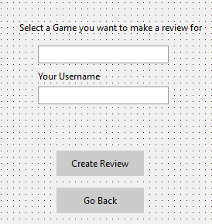

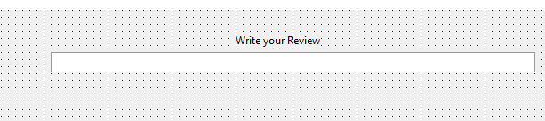

**Login and Sign-up Page**

**Login page**

The login page will retrieve the username and password entered by the user and proceed to validate this information against the data stored in the database. Upon submission, the system will compare the entered username and password with the corresponding records in the database to verify their accuracy. If the provided credentials match those in the database, the user will be granted access to the app. On the other hand if the entered details do not align with the database records, the system will display an error message indicating the unsuccessful login attempt.

**Sign-up Page**

The sign-up page will prompt the user to input a username, password, and email address. Upon submission, the system will first check if the chosen username is already present in the database. If the username is already in use, the system will request the user to select another username. Next, the system will verify the password provided by the user, ensuring it contains at least 8 characters, including at least one capital letter and one special character. This process enhances the security of user accounts by enforcing robust password requirements. After successful completion of these checks, the user's details will be added to the database, enabling them to access the system using their new login information

**Syndicate Page**

The clan system in a review app is essential for fostering a sense of community and trust among users. By creating clans, users with similar interests or preferences can come together to share and exchange valuable insights and recommendations. This system encourages meaningful interactions, allows users to form connections with like-minded individuals, and enhances the overall user experience. Additionally, clans can serve as a platform for users to seek advice, collaborate in parties for certain missions, and cultivate a supportive environment. Ultimately, the clan system helps to build a sense of belonging and camaraderie within the review app, leading to a more engaging and fulfilling user experience.

## 2.2) Structure of the Solution

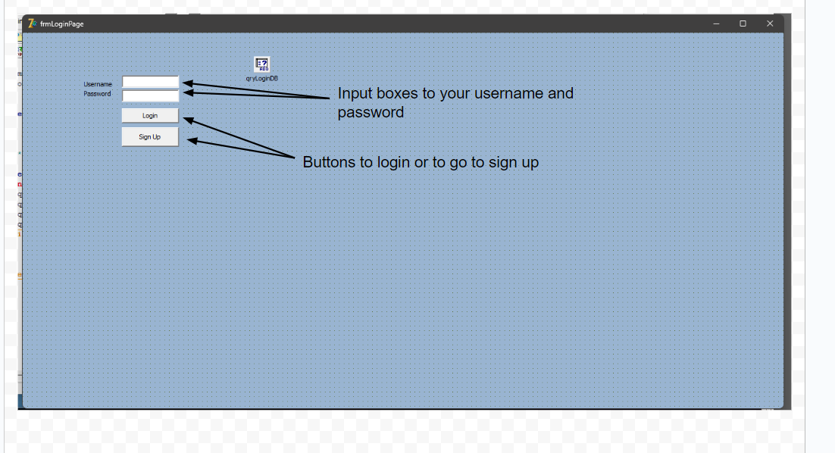

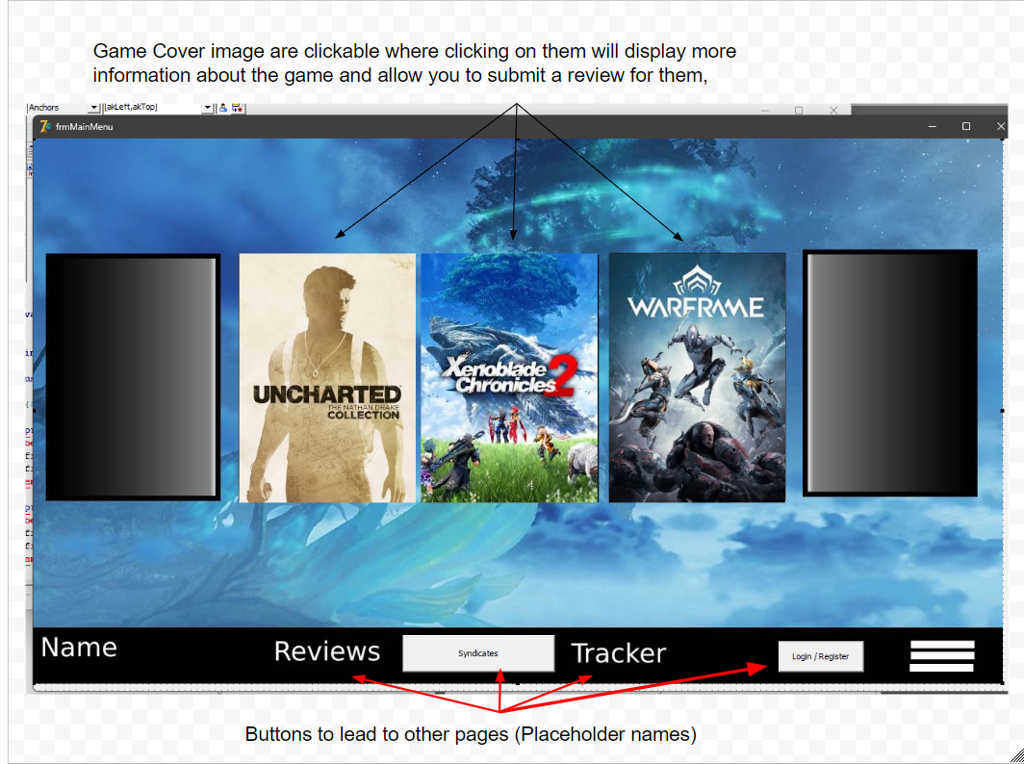

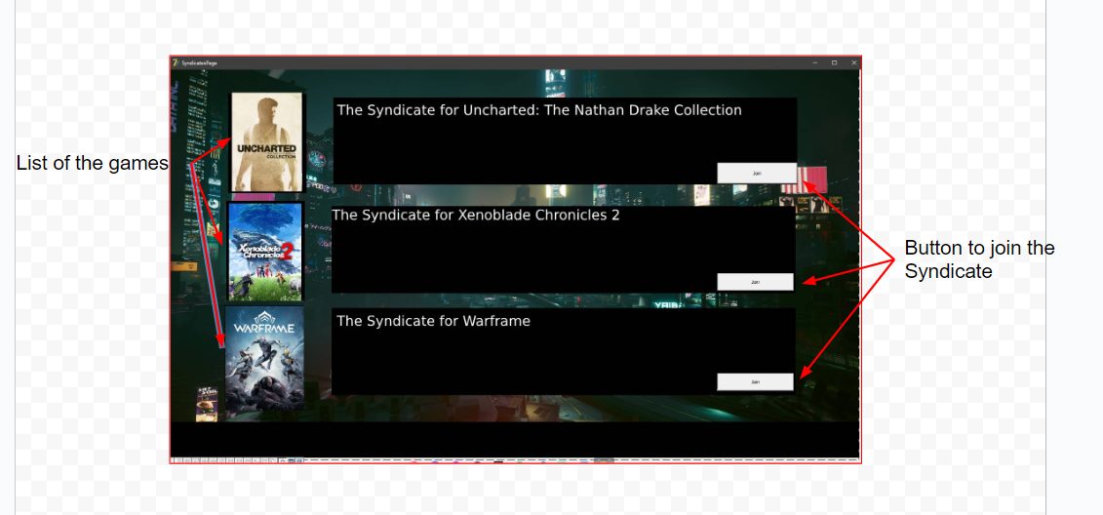

## 2.3) Algorithms

|  |
| --- |
| Procedure |
|  |
| Justification |
|  |

|  |
| --- |
| Procedure |
|  |
| Justification |
|  |

|  |
| --- |
| Procedure |
|  |
| Justification |
|  |

|  |
| --- |
| Procedure |
|  |
| Justification |
|  |

|  |
| --- |
| Procedure |
|  |
| Justification |
|  |

## 2.4) Usability features

|  |  |
| --- | --- |
| Usability feature | Justification |
| Black text for the buttons | The black text makes it easier to read against the grey buttons. |
| White text and a black box for information | Since the game pages have custom images, a box with contrasting text colour is required to allow the clients and users easily read the information. |
| Boxes being the same size | For design aspect to make the interface look more sleeker and cleaner. |
|  |  |
|  |  |
|  |  |

## 2.5) Key Variables / Data Structures

**Log in Page**

|  |  |  |  |
| --- | --- | --- | --- |
| Variable Name | Data Type | Global/Local Variable | Justification |
| Username | String | Local | The username is the unique identifier of the user thus each user will need to have a different username to any other user on the app. This will be checked against the database to make sure there is an account with this username |
| Password | String | Local | This will check against the database along side with the username to get each user into their respective accounts |
| Entered Username | String | Local | This will take the value of the of the username edit box to verify the username in the database. If the username entered does not match up with any records in the database, a message box will state that the username is incorrect |
| Entered Password | string | Local | This will take the value of the of the password edit box to verify the password in the database. If the password entered does not match up with any records in the database, a message box will state that the password is incorrect |

**Sign-up Page**

|  |  |  |  |
| --- | --- | --- | --- |
| Variable Name | Data Type | Global/Local Variable | Justification |
| Username | String | Local | This is the chosen username of the new user entering the app to make their account. This will also be checked against the database to make sure that the username is not duplicated. A message box will appear if the username already exist and asks them to change their username. |
| Email | String | Local | This is the email of the new user that will need to register with |
| Password | String | Local | This field is for ensuring user accounts are protected and to make sure person who is entering the account details is the user themselves and not someone impersonating them. |
| Password Requirements | String | Local | If the requirements are not followed, a message box will appear stating that the password format is not correct and should try entering a different password |

## 2.6) Test data during the iterative development

Login Tests

|  |  |  |  |  |
| --- | --- | --- | --- | --- |
| Test ID | Fields | Data Type | Test Data | Validation (If any) |
| LT-1 | Username | String | Admin |  |
| LT-2.1 | Password | String | @Admin123 | Special Characters |
| LT-2.2 | Password | String | @Admin123 | Minimum 8-character length |
| LT-2.3 | Password | String | @Admin123 | Capital Letter |
| LT-2.4 | Password | String | @Admin123 | Lowercase Letter |
| LT-2.5 | Password | String | @Admin123 | At least one number |

Sign up Tests

|  |  |  |  |  |
| --- | --- | --- | --- | --- |
| Test ID | Fields | Data Type | Test Data | Validation (If any) |
| ST-1 | Username | String | Admin |  |
| ST-2 | Email | String | admin@artifice.com |  |
| ST-3.1 | Password | String | @Admin123 | Special Characters |
| ST-3.2 | Password | String | @Admin123 | Minimum 8-character length |
| ST-3.3 | Password | String | @Admin123 | Capital Letter |
| ST-3.4 | Password | String | @Admin123 | Lowercase Letter |
| ST-3.5 | Password | String | @Admin123 | At least one number |

Main Menu Tests

|  |  |  |  |  |
| --- | --- | --- | --- | --- |
| Test ID | Fields | Data Type | Test Data | Validation (if any) |
| MMT-1 | Game Cover Images | Image | Clicking on Image |  |
| MMT-2 | Review Button | Button | Clicking on Button |  |
| MMT-3 | Log in Button | Button | Clicking on Button |  |
| MMT-4 | Syndicates Button | Button | Clicking on Button |  |
| MMT-5 |  |  |  |  |
| MMT-6 |  |  |  |  |

Reviews Page Tests

|  |  |  |  |  |
| --- | --- | --- | --- | --- |
| Test ID | Fields | Data Type | Test Data | Validation (if any) |
| RP-1.1 | Game Name | String | Combo box | Game is in the Database |
| RP-1.2 | Game Name | String | Edit Box | Game is in the Database |
| RP-2.1 | Review Author | String | Combo box | Author is in the database |
| RP-2.2 | Review Author | String | Edit Box | Author is in the database |
| RP-3 | Display Button | Button | Click on button |  |
| RP-4 | Review Display | String | Text Box |  |
| RP-5 | Go Back Button | Button | Click on button |  |
| RP-6 | Create Review Button | Button | Click on button |  |

Create Review Page

|  |  |  |  |  |
| --- | --- | --- | --- | --- |
| Test ID | Fields | Data Type | Test Data | Validation (if any) |
| CRP-1 | Game Select | String | Text Box |  |
| CRP-2 | Author’s Username | String | Text Box |  |
| CRP-3 | Create Review | Button | Click on button |  |
| CRP-4 | Go Back Button | Button | Click on button |  |
| CRP-5 | Create Review | Button | Click on button |  |
| CRP-6 |  |  |  |  |

Syndicates Page

|  |  |  |  |  |
| --- | --- | --- | --- | --- |
| Test ID | Fields | Data Type | Test Data | Validation (if any) |
| SP-1 | Join Syndicate Button | Button |  |  |
| SP-2 | Go Back Button | Button |  |  |
| SP-3 | Game Image leading back to description | Image |  |  |
| SP-4 |  |  |  |  |
| SP-5 |  |  |  |  |
| SP-6 |  |  |  |  |

## 2.7) Further data to be used in the post development phase

## 

# 3) Iterative development of a coded solution

## 3.1) Prototype versions

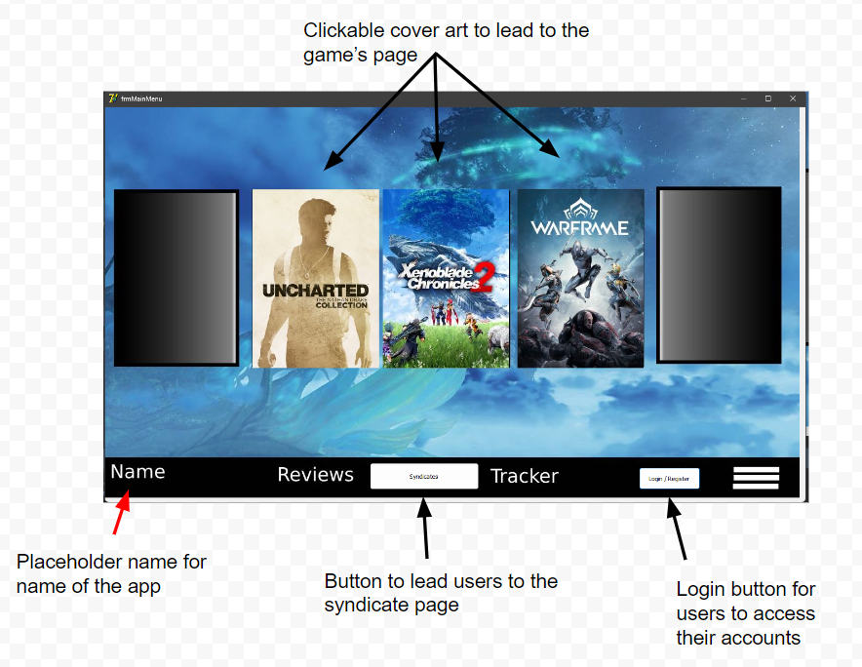

The main menu consists of two parts: Game Cover images that are the front and centre of the app and the navigation bar at the bottom to lead the user to the other functions of the app.

The game covers will display three game covers at a time with the two at the side will be half covered, and when highlighted, display and arrow indicating the page will scroll in that direction. Clicking on the cover of a game will display information about the game such as what it is about, a general description of the game entails and the option to go back to the previous page.

The navigation bar contains a place holder for the name of the app, buttons to lead the user to other sections of the site (Syndicates, Reviews, Tracker) and the option to log in. The hamburger menu of the right of the bar will lead users to more, optional but not the main features of the app, such as to go straight into creating a review of the app, displaying contact us information, news of the development and progress of the app and much more.

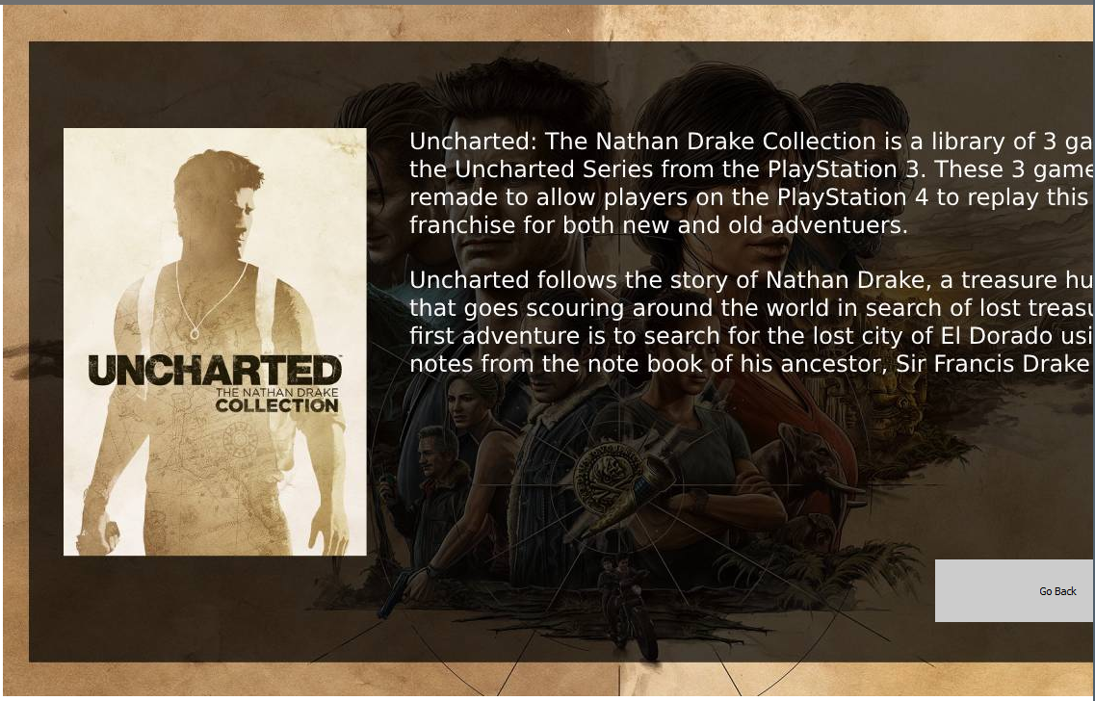

After clicking the game cover image, the user is lead to this page with information of the game. The page consists of the cover art the user has clicked, planned to have the cover art switch for more visuals listed and/or made by the publishers and a larger image in the background giving more of a hint to the game and its characters.

The information page has a semi-translucent box with text on it to describe the games origins (if it is a remake or a compilation of multiple games) and a short description of the game. The short description will contain slight spoilers mentioned at the start of the game and is meant to be a way to introduce and encourage user to try the game.

The page is meant to contain more information such as the Developers and Publishers, the date the game released, genre and what platforms the game is available on. The page will also contain a button to go to the Syndicate page for the game, see Reviews for the game and/or create a review for the game.

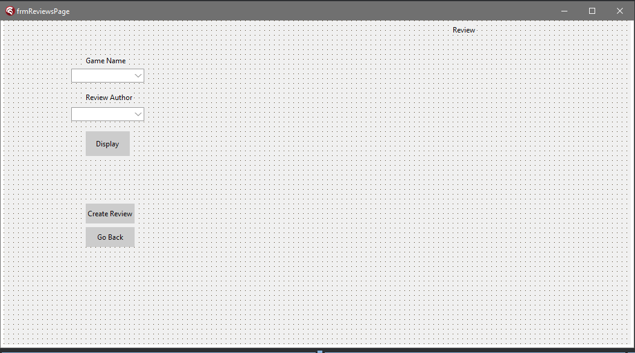

Sample of the “Review” Page to select from listed games and authors to display already written displays. Adding the list of the games and authors will have to come from the database table where both the names of games and authors are stored, both of which will link to a review for said game and then search the files of the reviews stored in the file system of the user, will display the review under the label “Review”

The users will have two other options to either go back to main menu or click on a button to bring them to the page to go and create a review.

## 3.2) Main Menu Prototype

#### 3.2.1) Main Menu Prototype 1

##### a)

|  |  |
| --- | --- |
| Main Menu Tests | When the program is launched, this is the landing page they will arrive at every time. They will be able to navigate throughout the main feature of the app such as accessing the reviews, clicking on game omages to see information of the game, joining and checking syndicates, accessing the tracker function and logging in/signing up. |

##### b) Main Menu

Annotated screenshot of the main page



##### c) implemented code

Code for the buttons and clickable game cover art

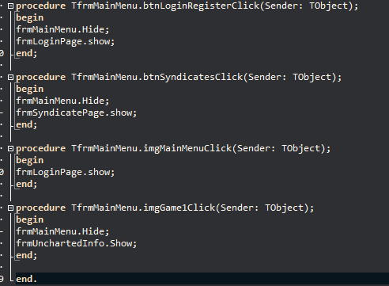

This code is for the various buttons on the main menu and a clickable image. Clicking the corresponding element will bring you to the page that you were requesting for whilst hiding the previous page you were on to not overflow the desktop with multiple pages at the same time.

##### d) Validation

no validations were carried out

##### e) Tests

|  |  |  |  |  |
| --- | --- | --- | --- | --- |
| Test ID | Fields | Data Type | Test Data | Validation (if any) |
| MMT-1 | Game Cover Images | Image | Clicking on Image |  |
| MMT-2 | Review Button | Button | Clicking on Button |  |
| MMT-3 | Log in Button | Button | Clicking on Button |  |
| MMT-4 | Syndicates Button | Button | Clicking on Button |  |

###### Results

## 3.3) Login Page Prototypes

#### 3.3.1) Login Prototype 1

##### a)

|  |  |
| --- | --- |
| Login Page Tests | Users will need to log into their accounts to access creating reviews, joining syndicates and using the tracker function. |

##### b) Login Page

Annotated screenshot of the login page

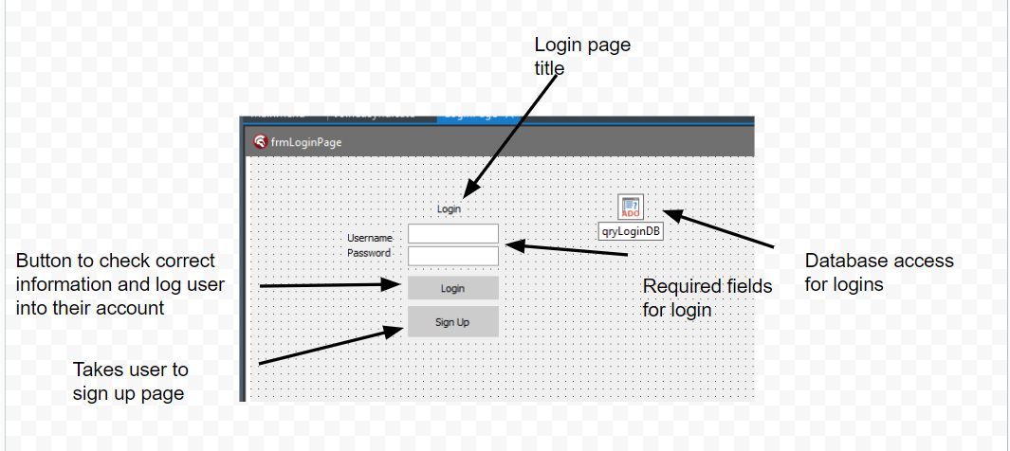

##### c) implemented code

Code for the buttons

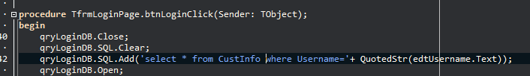

This piece of code takes the value entered in the username section of the form and adds it to an SQL code to check it against the database

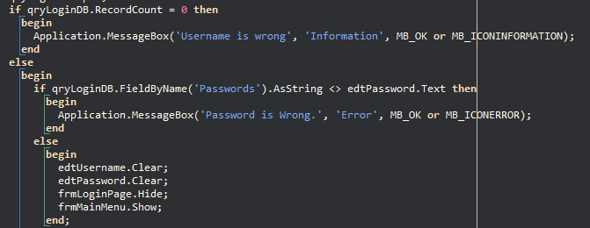

The code for logging will search the database for a table consisting of login information and searches for matching records to what the users have typed in. If there is an error (the information that the user typed in does not match any records in the database), it will throw a message box consisting of what is wrong/ mismatched.

Wrong username -> “Username is Wrong”

Wrong password -> “Password is Wrong”

The wrong username message box comes up as an information box whilst the wrong password box comes up with an error box.

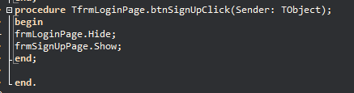

This part of the code is assigned to the sign-up button to send the user to the page to make an account for the app

##### d) Validations

##### e) test data

|  |  |  |  |  |
| --- | --- | --- | --- | --- |
| Test ID | Fields | Data Type | Test Data | Validation (If any) |
| LT-1 | Username | String | Admin |  |
| LT-2 | Email | String | admin@artifice.com |  |
| LT-3.1 | Password | String | @Admin123 | Special Characters |
| LT-3.2 | Password | String | @Admin123 | Minimum 8-character length |
| LT-3.3 | Password | String | @Admin123 | Capital Letter |
| LT-3.4 | Password | String | @Admin123 | Lowercase Letter |
| LT-3.5 | Password | String | @Admin123 | At least one number |

###### Test Results

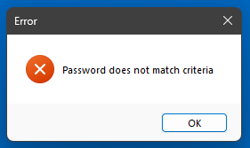

When ST-3.1 to ST-3.5 is not followed, the password fails to meet the specified requirements and is deemed invalid, a message box appears on the screen to notify the user. This message box serves as a form of feedback, alerting the user to the specific issue with the password. It may include details about the password requirements that were not met, such as minimum length, special character usage, or other criteria. Additionally, the message box might offer guidance or suggestions to help the user create a valid password.

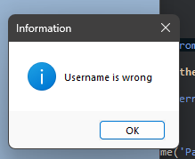

When a username is not found within a database, a message box is triggered to inform the user that the username is incorrect. This message box serves as a means of providing feedback, telling the user that what they entered was wrong and that they should double check what they have entered.

## 3.4) Sign-Up Page Prototype

Annotated screenshot of the sign-up page

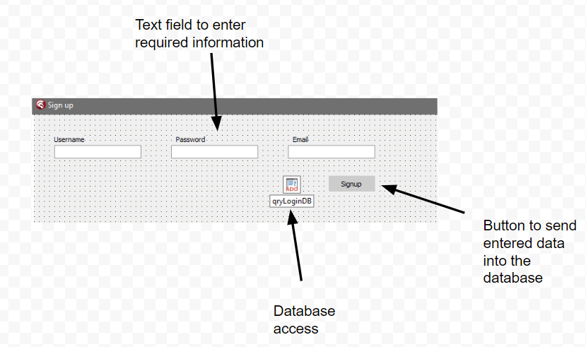

There are currently no checks in the sign-up page which is a requirement that will be added in the next prototype.

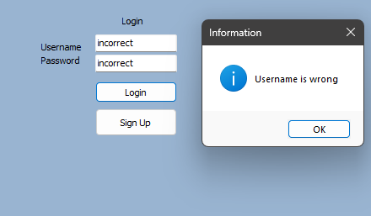

Entering incorrect information in both fields will result in the output that only the username is wrong.

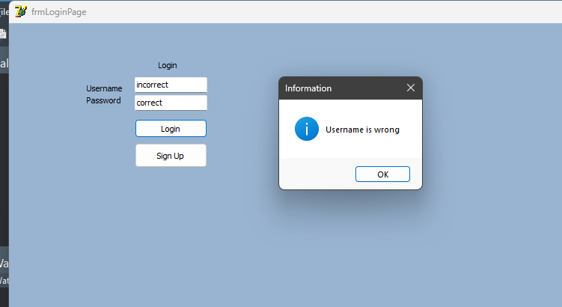

Program stops user from entering further when incorrect user name is entered. Program also mentions only the username is wrong when both are wrong

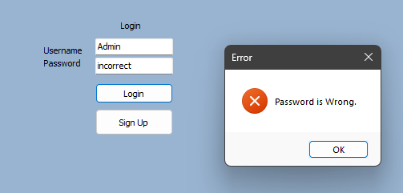

Program notifies user when the password is incorrect.

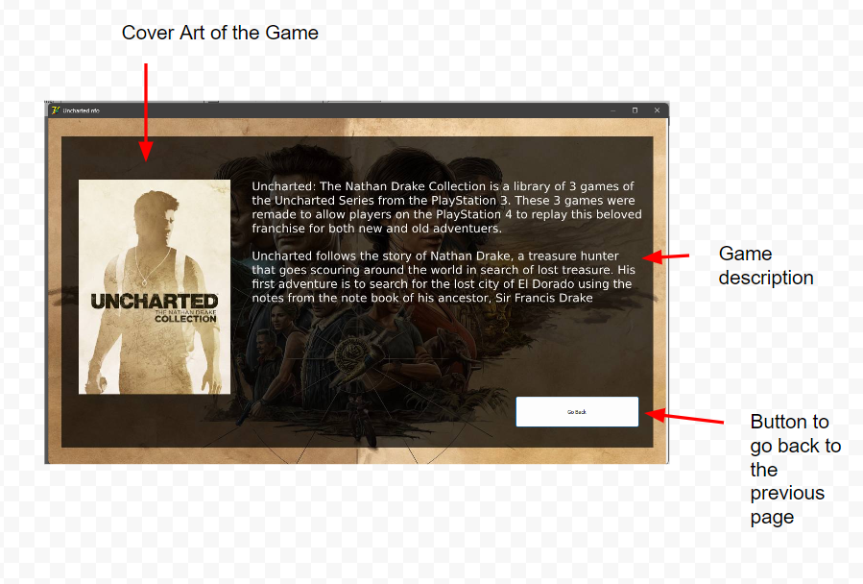

When clicking on the game cover art, it brings you a page with a quick synopsis.



Syndicates are groups you can join to get information of updates to the games but due to the time constraint, the news will not be added in the initial release. The page is also missing an option to return to the previous page.

## 3.5) Display Review Prototypes

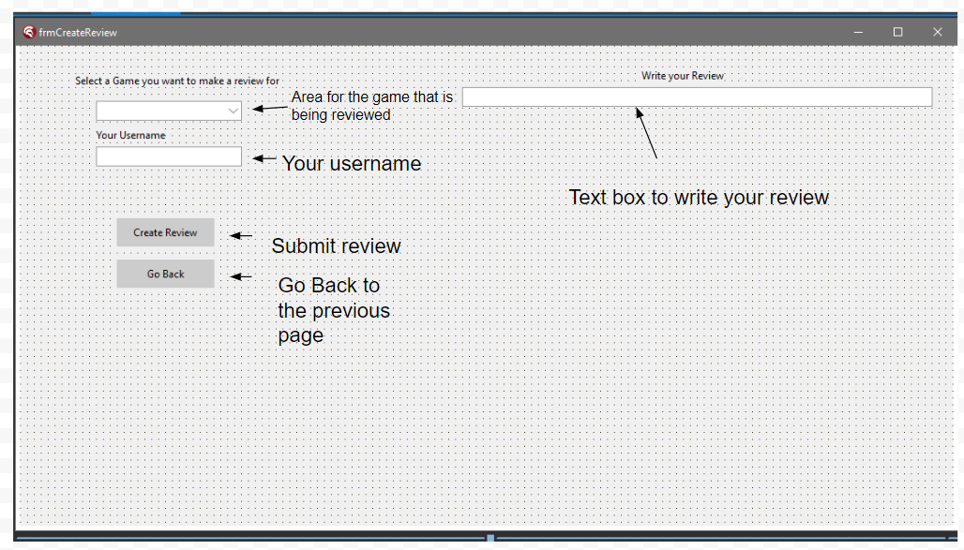

Annotated screenshot of the review creation page.

## 3.6) Create Review Protoypes

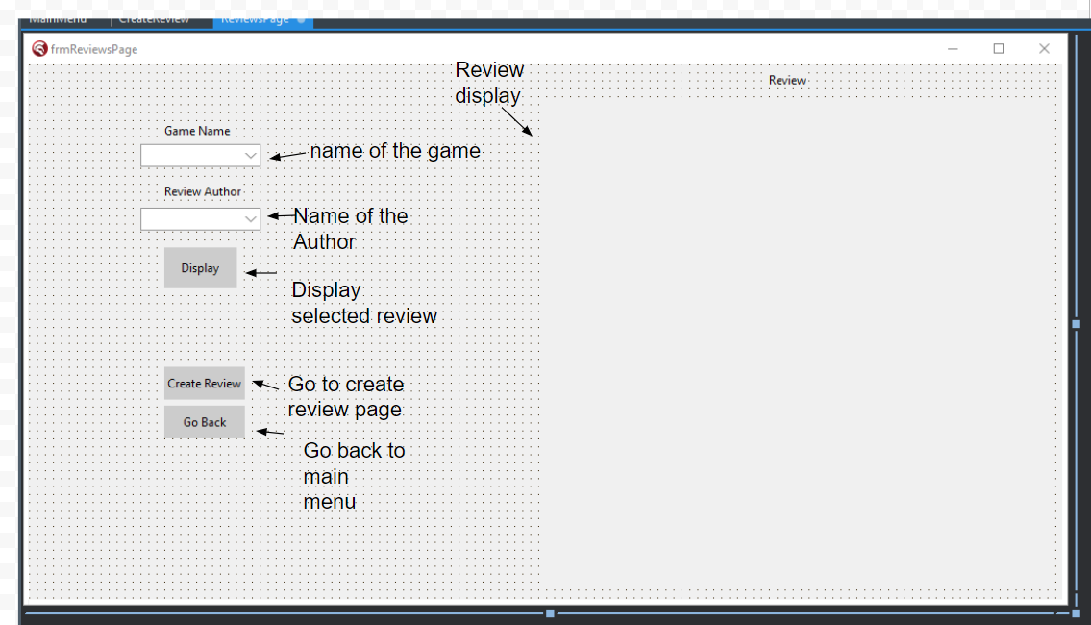

Annotated screenshot of the review viewing page.

## 3.7) Review of Solution

# 4) Testing to inform development

## 4.1) Testing at each stage of the iterative development process

# 5) Testing to inform evaluation

## 5.1) System Testing and End user testing

# 6) Evaluation of solution

## 6.1) Evaluate the solution

## 6.2) Further development.

## 6.3) Effectiveness of usability features.

## 6.4) Maintenance issues and limitations of the solution.

## 6.5) Limitations and potential improvements / changes.